Batch: A2 Roll No.: 16010122034

Experiment / assignment / tutorial No._______

TITLE: Study of RISC and CISC Architecture
AIM: Understanding RISC and CISC Architecture
_______________________________________________________________
Expected OUTCOME of Experiment: (Mentions the CO/CO’s attained)
CO2- Understand the Central processing unit with addressing modes and working of control
unit in depth
CO4- Summarize Input output techniques and multiprocessor configurations
__________________________________________________________________
Books/ Journals/ Websites referred:

- Carl Hamacher, Zvonko Vranesic and Safwat Zaky, “Computer Organization”, Fifth Edition, TataMcGraw-Hill.
- William Stallings, “Computer Organization and Architecture: Designing for Performance”, Eighth Edition, Pearson.
3. Dr. M. Usha, T. S. Srikanth, “Computer System Architecture and Organization”, First Edition, Wiley-India.
_____________________________________________________________________

Pre Lab/ Prior Concepts:

Reduced Set Instruction Set Architecture (RISC)
The main idea behind is to make hardware simpler by using an instruction set composed of a few basic steps for loading, evaluating and storing operations just like a load command will load data, store command will store the data.
Complex Instruction Set Architecture (CISC)
The main idea is that a single instruction will do all loading, evaluating and storing operations just like a multiplication command will do stuff like loading data, evaluating and storing it, hence it’s complex.Both approaches try to increase the CPU performance

RISC Architecture

- Diagram of RISC Architecture:
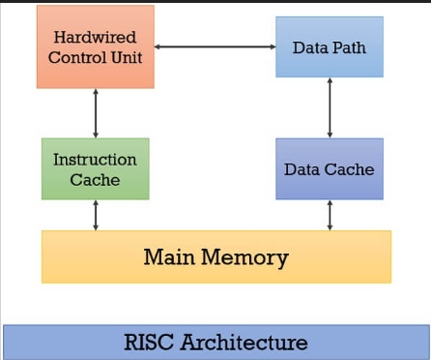

Brief Explanation of each component
A RISC (Reduced Instruction Set Computer) architecture is characterized by its simplicity and efficiency in executing instructions. It typically consists of several key components, each with a specific role in the processor's operation. RISC components are:
- Instruction Fetch (IF):
The IF stage is responsible for fetching the next instruction from memory. It typically involves the program counter (PC) being updated to the address of the next instruction to be executed.

- Instruction Decode (ID):
In the ID stage, the fetched instruction is decoded to determine the operation to be performed and the operands involved. This stage also includes register file access to read the necessary registers.

- Execution (EX):
The EX stage carries out the actual computation or operation specified by the instruction. It may involve arithmetic operations, logical operations, or data manipulation.

- Memory Access (MEM):
If the instruction involves accessing memory (e.g., load or store operations), the MEM stage is responsible for memory address calculation and data transfer to/from memory.

- Write-Back (WB):
In the WB stage, the results of the instruction are written back to the destination registers. This is where the processor updates its register file with the computed values.

- Control Unit (CU):
The control unit manages the sequencing and control of the processor's operations. It determines which stage to execute next and controls data flow between stages.

- Register File:
RISC architectures typically have a small set of general-purpose registers that are used to store data temporarily during program execution. The register file is responsible for reading from and writing to these registers.
- ALU (Arithmetic Logic Unit):
The ALU is responsible for performing arithmetic and logical operations, such as addition, subtraction, bitwise operations, and comparisons.

- Data Cache:
RISC processors often include a data cache to speed up memory access. The data cache stores frequently accessed data to reduce the need to fetch data from slower main memory.

- Control Signals:
Various control signals are used to coordinate the operation of different components within the processor. These signals determine when to enable specific operations and data transfers.

- RISC Processor Instruction Set Examples with explanation (Any 2)
RISC instructions are simple and are of fixed size. Each RISC instruction engages a single memory word. RISC instructions operate on processor registers only. The instructions that have arithmetic and logic operation should have their operand either in the processor register or should be given directly in the instruction.
Load destination, Source
- Example Load R2, A // memory to register
The load instruction above will load the operand present at memory location A to the processor register R2. The Store instruction stores the operand back to the memory. Generally, the Store instruction is used to store the intermediate result or the final result in the memory. It is of the form:
Store source, destination

- Example Store R2, A // register to memory
The Store instruction above will store the content in register R2 into the A a memory location.
It can be observed that in the example of Load and Store instruction operand side of both instructions appears the same as R2, A. But, the source and destination order of Store instruction is reversed in Load instruction. RISC instruction has simple addressing modes. Some of them are mentioned below:
- Immediate addressing mode: This addressing mode explicitly specifies the operand in the instruction. Like:
Add R4, R2, #200
The above instruction will add 200 to the content of R2 and store the result in R4.

- Register addressing mode: This addressing mode describes the registers holding the operands.
Add R3, R3, R4
The above instruction will add the content of register R4 to the content of register R3 and store the result in R3.

- Absolute addressing mode: This addressing mode describes a name for a memory location in the instruction. It is used to declare global variables in the program.
Integer A, B, SUM;
This instruction will allocate memory to variable A, B, SUM.

- Register Indirect addressing mode: This addressing mode describes the register which has the address of the actual operand in the instruction. It is similar to the pointers in HLL.
Load R2, (R3):
This instruction will load the register R2 with the content, whose address is mentioned in register R3.

- Index addressing mode: This addressing mode provides a register in the instruction, to which when we add a constant, obtain the address of the actual operand. It is similar to the array of HLL.
Load R2, 4(R3)
This instruction will load the register R2 with the content present at the location obtained by adding 4 to the content of register R3.
CISC Architecture

- Diagram of CISC Architecture:

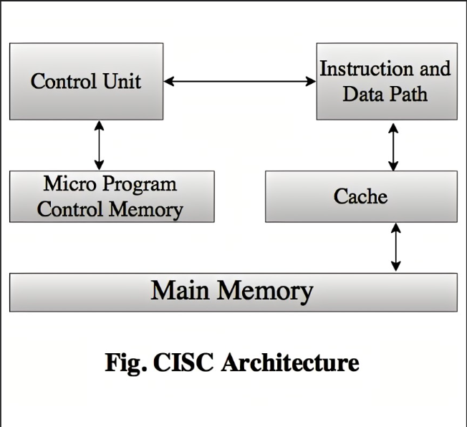
- Brief Explanation of each component
CISC (Complex Instruction Set Computer) is an architecture that contrasts with RISC (Reduced Instruction Set Computer). CISC processors have a more extensive and complex instruction set, often including multi-step instructions that perform a variety of operations. Brief explanation of the key components and characteristics of CISC architecture:

- Complex Instructions:
CISC processors feature a wide range of complex and specialized instructions. These instructions can perform multiple operations in a single instruction, making them powerful but also complex to decode and execute.

- Memory Addressing Modes:
CISC processors often support a variety of memory addressing modes, allowing instructions to access memory in diverse ways. These addressing modes provide flexibility but can also add complexity to the instruction set.

- Microprogramming:
CISC processors often employ microcode, a low-level control program that interprets and executes complex instructions. Microcode is used to implement the various steps within a single CISC instruction.

- Variable-Length Instructions:
CISC instructions can vary in length, which adds complexity to instruction decoding. The variable-length instructions are more challenging to fetch and decode compared to fixed-length instructions found in RISC architectures.

- Pipelining:
Some CISC processors incorporate pipelining, which is a technique to improve instruction throughput by breaking down instruction execution into multiple stages. However, CISC pipelining can be more complex due to the varying lengths of instructions.

- Memory Hierarchy:
CISC processors often have more extensive memory hierarchies, including various levels of cache memory, virtual memory systems, and memory management units (MMUs) to handle complex memory access patterns.

- Complex Control Unit:
The control unit in CISC processors is more intricate due to the need to decode and execute a wide array of complex instructions. It manages the control signals for various execution units within the processor.

- Register File:
CISC architectures typically have a larger number of general-purpose and specialized registers, allowing for more complex operations. These registers are used for data manipulation and storage during program execution.

- Higher Hardware Complexity:
CISC processors tend to be more complex in terms of hardware design, including specialized execution units, coprocessors, and additional components to support the extensive instruction set.

- Instruction Decoding:
Decoding CISC instructions can be more challenging because of their complexity and variable lengths. This requires more circuitry for efficient instruction decoding.

- CISC Processor Instruction Set Examples with explanation (Any 2)
- Move: The Move instruction is used to transfer data from one location to another. It can move an immediate operand to a memory location or a register, transfer the operand between two memory locations, or between two registers. The general format of Move instruction is Move destination, source. It has five basic addressing modes like Immediate mode, direct/absolute mode, register mode, Indirect mode, and Index mode. CISC instruction set has some additional addressing modes like “auto increment mode”, “auto decrement mode”, and “relative mode”

- String Instructions: String instructions are used to manipulate strings of characters or bytes. They can perform operations like copying, comparing, and searching strings. The general format of string instructions is:

REP prefix
operation
Here, REP prefix specifies the number of times the operation should be repeated. The operation can be any one of the following: MOVSB, MOVSW, MOVSD, CMPSB, CMPSW, CMPSD, SCASB, SCASW, or SCASD. These operations are used to move byte/word/doubleword from one location to another, compare byte/word/doubleword from one location to another, or scan byte/word/doubleword for a specific value

Post Lab Descriptive Questions
Write a tabular comparative analysis of RISC v/s CISC

RISC | CISC
RISC stands for Reduced Instruction Set Computer. | CISC stands for Complex Instruction Set Computer.
RISC processors have a small and simple instruction set. | CISC processors have a large and complex instruction set.
RISC instructions are simple in nature and occupy a single word in memory. | CISC instructions are complex in nature and occupy more than a single word in memory.
RISC processors execute instructions faster by simplifying the instruction set and reducing the number of cycles per instruction. | CISC processors minimize the program size by reducing the number of instructions in a program.
RISC chips require several transistors, making it cheaper to design and reduce the execution time for instruction. | CISC chips require fewer transistors, making it more expensive to design and increasing the execution time for instruction.
RISC processors are optimized with multiple registers that can be used to store instruction and quickly respond to the computer and minimize interaction with computer memory. | CISC processors have a small number of registers that are used to store instruction and data, which increases interaction with computer memory.

Conclusion:
Therefore information on RISC and CISC was obtained and learnt successfully.

Date: _____________ Signature of faculty in-charge

